**Kalinga Institute of Industrial Technology**

**Ankit Raj**

**1906534**

**DM Assignment**

**Activity - 4**

**Cyclone**

In meteorological terms, a cyclone is a wind device that rotates inwards (counter-clockwise in the Northern Hemisphere and clockwise in the Southern) around a robust low-stress center. Simply positioned, d-spiraling winds that rotate about a low-pressure quarter is known as a cyclone.Generally, when winds upward thrust above 118 kmph, it is known as a cyclone.

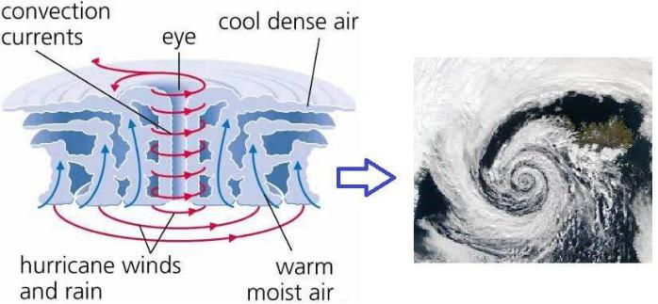

**Impact of Cyclone:**

* Strong winds cause damages to infrastructure, uproots trees, and lead to other catastrophes.
* Torrential rainfall leads to unprecedented floods and damages to houses and buildings.
* Due to storm surge, seawater levels rise, and the coastal areas are exposed to floods.
* The rise in seawater level also erodes beaches and embankments.
* Severe cyclonic storms resulting in floods can damage vegetation and livestock.
* Due to the strong winds and flood conditions, the soil becomes infertile.

**OBJECTIVE**

* To protect and minimize the loss of lives and property/ infrastructure from cyclones.
* To minimize the suffering of people due to cyclones.
* To build the capacity of all stakeholders in the State to cope with the cyclones and promote community based disaster management.
* Develop efficient cyclone response/relief mechanism in the State.
* To provide clarity on roles and responsibilities for
* all stakeholders concerned with cyclone management.
* To ensure co-ordination by promoting productive partnership with all other agencies related to cyclone management.

**ACTION-PLAN**

**Pre-Cyclone Preparations:**

* + 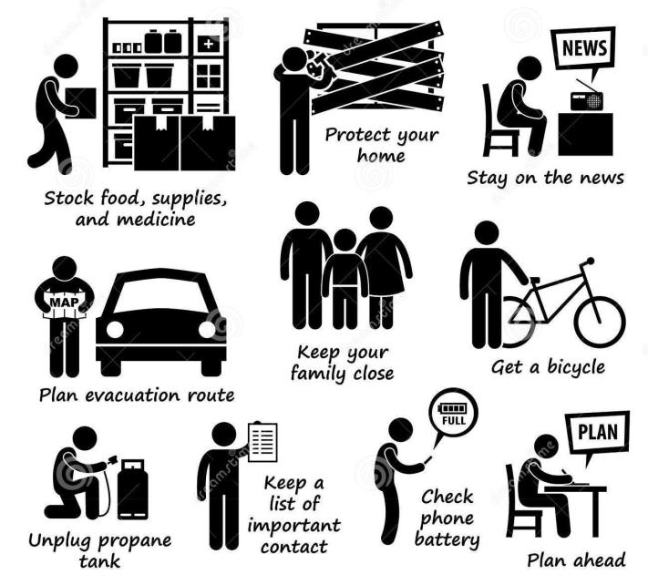Check the house
  + Secure loose tiles and carry out repairs of doors and windows
  + Remove dead branches or dying trees close to the house
  + Anchor removable objects such as lumber piles, loose tin sheets, loose bricks, garbage cans, sign-boards etc. which can fly in strong winds.
  + Keep some wooden boards ready so that glass windows can be boarded if needed.
  + Keep a hurricane lantern filled with kerosene, battery operated torches and enough dry cells.
  + Demolish condemned buildings.
  + Keep some extra batteries for transistors.
  + Keep some dry non-perishable food always ready for use in emergency.

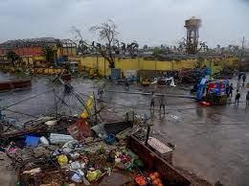

***When cyclone alerts and warnings are communicated:***

* Listen to the radio (All India Radio stations give weather warnings).
* Keep monitoring the warnings. This will help you prepare for a cyclone emergency.
* Pass the information to others.Ignore rumour and do not spread them; this will help to avoid panic situations.
* Believe in the official information.
* When a cyclone alert is on for your area continue normal working but stay alert to the radio warnings.
* Stay alert for the next 24 hours as a cyclone alert means that the danger is within 24 hours.

**When Cyclone Hits:**

* Drink only treated or boiled or chlorinated water! Chances of outbreaks of waterborne diseases increase drastically after cyclones and the resultant flooding events.
* Stay indoors until the danger has completely passed. If you are in an emergency shelter, remain there until informed by district authorities that you may return home.
* Clear your house and premises of debris immediately.Do not enter damaged buildings.Keep away from the disaster-hit areas unless you are required to aid and assist.
* Watch out for broken electric poles, wires and other sharp objects. Any loose and dangling wires from the lamp post should be strictly avoided, as they may have electric current.
* Avoid driving immediately after the cyclone has passed. If you have to drive, do it carefully.Get inoculated against diseases immediately.
* Do not step into waterlogged areas since chances of electrocution, reptile bites and injuries remain high.
* See if there are any animals in distress around your area. Help them to safety.Clear any and all water stagnation around your locality to avoid the spread of vector-borne diseases.
* Keep an eye out for anti-social elements. Any such activities should be prevented and reported to the police immediately.
* Report the losses to the appropriate authorities.
* Be calm. Your ability to meet emergencies, even after the disaster has passed, will inspire and help others.